

GenC Intern Skilling
Program Guidelines - 2025

Table of Contents

1 Introduction 4
2 Scope 4
3 Purpose 4
4 GenC Program Overview 4
5 Acronyms and Definitions 6
Acronyms 6
Definitions 6
6 Skilling completion criteria for GenC Interns 7
6.1 Technical Competencies 7
6.1.1 Stage 1 8
6.1.2 Stage 2 and beyond (Advanced skilling stages) 8
6.1.2.1 RAG Definition 9
6.1.2.2 Skilling completion criteria from Stage 2 and attempt eligibility 9
6.1.2.3 Gating criteria Beyond Stage 2 10
6.1.3 Exceptions to evaluation components 10
6.1.3.1 EPS B.COM hiring selects 10
Note 10
7 Attendance health Status 11
8 Internship stipend 11
9 GenC Internship skilling program guidelines 11
9.1 Code of Ethics - Guiding Principles 13
9.1.1 Employee Relations matters 13
9.2 Attendance Health status Guidelines 13
9.3 AHS RAG 14
9.4 AHS Consequence 14
9.4.1 Internship leave policy 14
9.4.2 Break Scenario 15
9.5 Integrity in Assessments 15
9.5.1 What constitutes Malpractice 16
9.6 Deployment guidelines 16
9.7 Communication protocols 17
9.7.1 GenC Program communication Escalation Matrix 17
9.7.2 Mail format 17
10 GenC Grievance cell 18
10.1 How does the grievance cell work? 18
10.2 Grievance Categories 18
11 Feedback communication to the GenC 19
12 Moonlighting guidelines for Internship Candidates 19
13 Outliers/Exceptions 20

Introduction
The Generation Cognizant Program (GenC Program) caters to the Entry Level Training within Cognizant in India. It stretches across the entire timeline of a campus hire's learning journey; from the time they accept the offer from the company to the first year of their tenure in the organization. There is a robust learning strategy put in place across each of the stages:

- Pre-Onboarding (Early Engagement, Campus engagement, Internship, Certified skill development)
- GenC Internship training
- Year One Enablement
- Continuous Role Development

Scope
This document covers the guidelines for the GenC Internship at Cognizant in India for both On-Campus and Off-Campus selects going through the Cognizant GenC skilling program enablement via Classroom, Virtual, or Hybrid (Classroom & Virtual) modes in the year 2025. These guidelines are applicable to all types of skilling programs (Skilling/Re-skilling pre & post onboarding to the skilling program).

The duration and exit criteria of the GenC Internship will be determined by the curriculum track to which the GenC is mapped as per the business demand. (Refer to Stage 2 for details)

Purpose
The purpose of this document is to define the approach towards Cognizant GenC Internship 2025 skilling completion from the LnD GenC Program standpoint.

The GenC curriculum is designed with a focus on enabling GenC Intern candidates to incorporate the skills acquired by developing real-time projects/use cases, as well as significantly improving their professional skills as they progress through the program.

GenC Program Overview
The GenC (Generation Cognizant) Program assures skill capability in our fresh hires (GenCs) towards business readiness at Cognizant. This program spans the entire duration of the GenCs learning journey, from the time they accept the Cognizant offer, through the first-year completion as an FTE in the organization. There is a robust learning strategy put in place across four phases.
In the Cognizant GenC skilling program, the intern candidates are provided with a learning path, and their performance is assessed based on the milestones in the curriculum. This includes meeting the gating criteria for the assigned curriculum, completing learning assessments, and hands-on assignments as per the given schedule, and adhering to the skilling program guidelines.

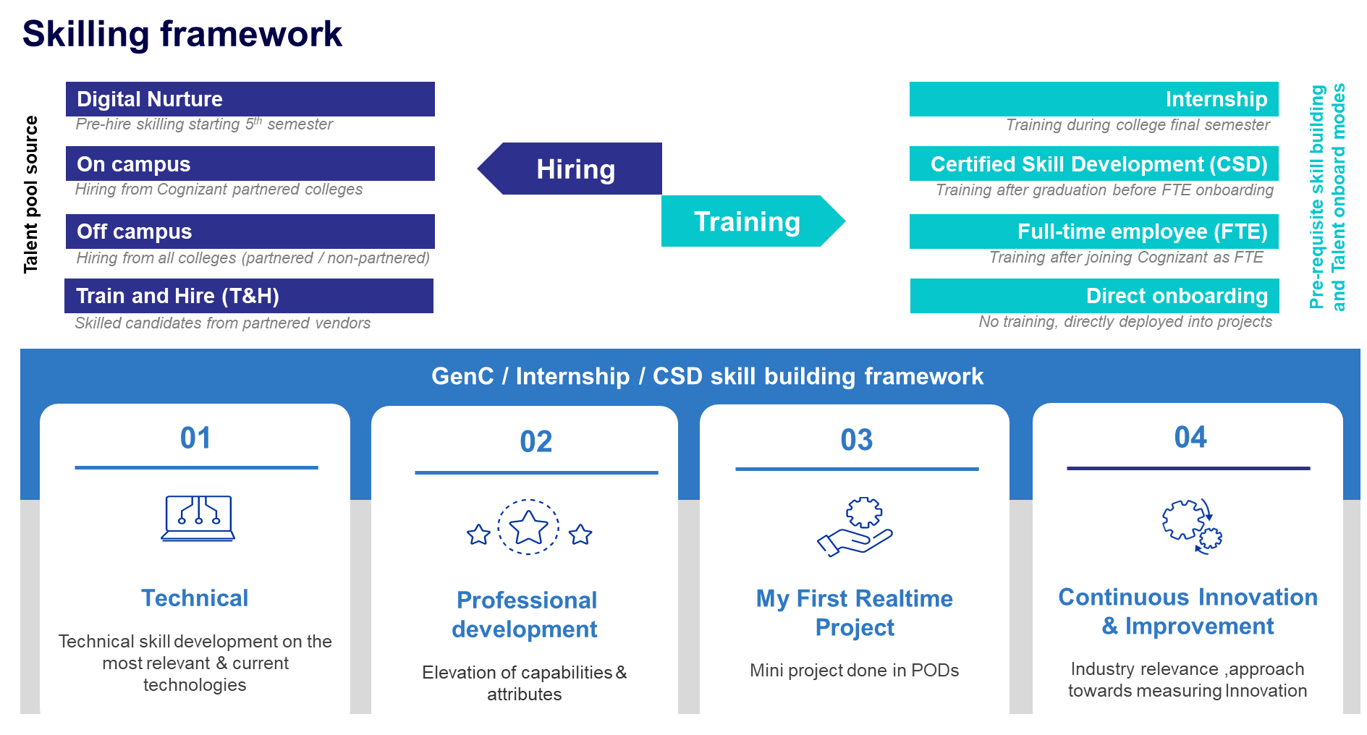

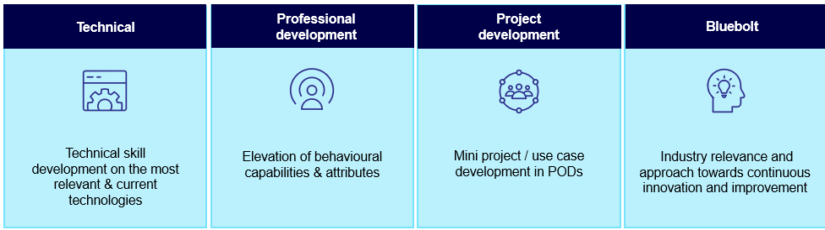

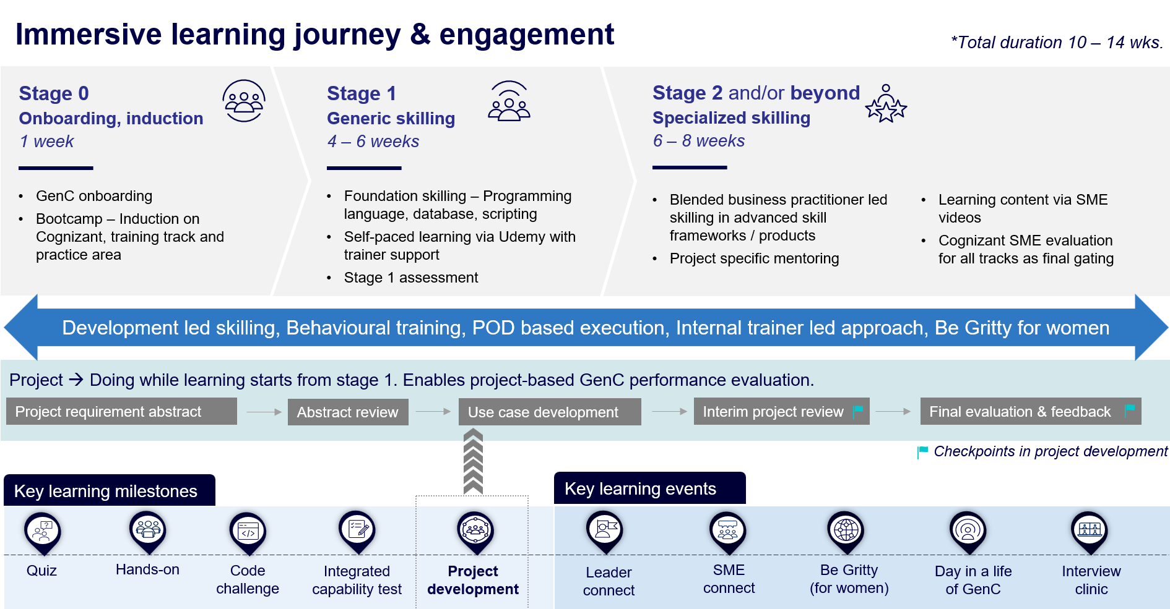

Acronyms and Definitions
Few of the acronyms and/or their definitions provided here may not have been used in this document but have been included for easy reference.

Acronyms
- Acronym | - Description
GenC | Generation Cognizant
SL | Service Line
BU | Business Unit
FTE | Full Time Employee
PHS | Performance Health Status
AHS | Attendance Health Status (Score)
RAG | Red, Amber, Green
LOI | Letter of Intent

Definitions
Component | Description | Examples
Learning and Evaluation Components | The broad parameters that will be applicable for all types of enablement, based on which the evaluation and completion criteria would be determined. | Continuous Learning (Technical & Behavioral – if applicable)  Hands-on exercises  Qualifier assessments  Interim Technical & Project Evaluation  Final Technical & Project Evaluation
Type of Curriculum | The learning path can follow any of the predefined structures as designed by Cognizant GenC skilling program.  Alternatively, based on the business demand, to meet the expectations of learning outcomes, customizations would be applied to the existing defined learning path [a joint venture between the Service Line (SL) and GenC program team]  A completely niche learning path could be designed by the Business team [referred to as Service Line (SL) Driven]. | Standard Skill Tracks  GenC program driven  Business Defined Skill Tracks  GenC program + SL driven  SL Driven
Minimum Score/ Expected Status | The score/status that the GenC should obtain to clear a particular Evaluation Component. The score/Status indicates a completion or a skill/technical score, as per the applicability, for the Evaluation Component. | All score-based Assessments – Evaluation score of 70% and above  PHS to successfully complete the training will be “Green”
Number of Attempts | Any GenC who has not obtained the pre-defined minimum percentage to clear the Evaluation components will be eligible for reattempt, as applicable. The number of reattempts would be defined for respective evaluation components in the learning path. | 1 or 2, as prescribed for the Evaluation Components
Performance Health Status | Status determined based on the performance by GenC in the evaluation components, applicable for the learning path | Green/Amber /Red status  PHS to successfully complete the training will be “Green”
AHS  Attendance Health Status | Cumulative attendance status of the GenC at physical location and virtual training. | Green/Amber /Red status  Time at Office – 10 hours across all India locations [9 hours for Kolkata and NCR]  TruTime Compliance = “Green” (min 9 hours/day)  Attendance in mandatory ILT/VILT sessions

Skilling completion criteria for GenC Interns

Technical Competencies
Every GenC is mapped to a technical track based on business demand and provided systematic training to develop their technical skills. Each technical track has a defined curriculum, which is oriented to the GenCs at the beginning of the technical skilling phase. For successful completion of the skilling program, the GenCs are expected to demonstrate their comprehension and ability to implement technical concepts as per the defined curriculum.
The details on the completion criteria relating to technical skilling across fundamental and advanced levels are explained below:
The technical performance skilling and evaluation will happen at two levels:
- Stage 1 [Fundamentals]
- Stage 2 and beyond as applicable [Advanced skilling stages]

Stage 1

Stage 1 in the training curriculum of each track serves as a foundational phase that supports progression to the advanced skilling stages. While it is not a qualifier for exit, successful completion of Stage 1 equips trainees with the essential skills needed for further stage
- The GenC Interns are expected to obtain a score of >=70% score in the stage 1 assessment.
      - It is recommended that trainees complete 100% of the hands-on exercises assigned in the Stage 1 curriculum before appearing for the Stage 1 assessment.
      - Catch-up instances will be provided to complete hands-on exercises and attempt stage1 assessment.

Stage 1 assessment | GenC Type
 | Interns
>= 70% in stage 1 assessment | Proceed with stage 2 learning
< 70% in stage 1 assessment | Candidates will be provided with 2 additional attempts while they proceed with stage 2 in parallel.

Successful completion of Stage 1 is recommended. Depending on the SL track, trainees who do not pass Stage 1 may be held back (BU discretion) from attempting the final evaluation, which could result in not fulfilling the internship completion criteria

Stage 2 and beyond (Advanced skilling stages)

From Stage 2, the candidates' technical proficiency and their ability to implement the skills will be evaluated to determine their Performance Health Status (PHS) based on a one-to-one evaluation by a Subject Matter Expert (SME). The SME evaluation will be a single event covering both technical and project implementation aspects conducted at two checkpoints during the skilling phase: (i) Interim Evaluation (ii) Final evaluation.
- The interim evaluation is conducted at a logical midpoint during the advanced skilling stages. A candidate's learning progress is assessed during the interim evaluation, and an interim PHS is provided along with feedback to assist them in achieving their final evaluation goals.
- The final evaluation is conducted at the end of the technical skilling phase and the candidate is assessed on the entire set of skills he has learned in the curriculum. Final evaluation results are presented in Red/Amber/Green as Performance Health Status (PHS).
At the end of technical skilling phase, the GenC Intern candidates are expected to have a performance health status of 'Green' to be eligible for successful completion of the GenC skilling program.

If the PHS is Red/Amber after the final evaluation, candidate will be de-enrolled from the GenC skilling program and LOI will be revoked. The candidate will not be eligible for FTE offer.

RAG Definition

Red | Candidate cannot answer the basic questions asked on specific technical skill.  Candidate has implemented a few project requirements and is unable to answer questions on the project clearly.  Candidate cannot respond in complete sentences to the questions asked, struggles to find the words and is unable to comprehend questions, poor attitude towards learning,
Amber | Candidate can answer basic questions and some of scenario-based questions without detailed explanation.  Candidate has implemented few of project requirements and able to present, explain and answer basic questions on project.  Candidate is able to respond in complete sentences to questions, using too many fillers, having good attitude and finds difficult to comprehend the questions.
Green | Candidate has good understanding on skill and able to answer most of the basic and scenario-based questions.  Candidate has implemented most of the project requirements, able to present the requirement well and answer the questions related to project.  Candidate speaks clearly with right attitude, maintains eye contacts, and speaks confidently and able to articulate his/her thoughts.

Skilling completion criteria from Stage 2 and attempt eligibility

Interim Evaluation | Final Evaluation (Attempt 1) | Final Evaluation  (Attempt 2) | Final RAG
Green | Green | NA | Green
Green | Amber | Green | Green
Green | Amber | Amber or Red | Amber or Red
Green | Red | Green | Green
Green | Red | Amber or Red | Amber or Red
Amber | Green | NA | Green
Amber | Amber | Green | Green
Amber | Amber | Amber or Red | Amber or Red
Amber | Red | Amber or Red | Amber or Red
Red | Green | NA | Green
Red | Amber | Green | Green
Red | Amber | Amber or Red | Amber or Red
Red | Red | Not Eligible | Red

Evaluation components may be excluded, modified, or excluded based on SL discretion and GenC program head approval. Refer section 7.1.3

Gating criteria Beyond Stage 2

GenC/Intern Training | Overall Evaluation Components | Pass Criteria | Evaluation Done by
Performance Health Status - PHS  (Only from Stage 2) | Interim Evaluation  (Project + Technical)  (Refer curriculum details for SL specific evaluation components) | Passing criteria & the eligible number of attempts are as given in 6.1.2.2 | BU SME
Final Evaluation
(Project + Technical)
(Refer curriculum details for SL specific evaluation components)

Exceptions to evaluation components

EPS B.COM hiring selects

Candidates with a B. Com background who are part of the EPS OSP track and undergoing functional skilling will not be subject to interim or final evaluations. Instead, their progress will be monitored through weekly assessment reports provided by the vendor. A consolidated final report, compiled from these weekly assessments, will serve as the basis for selection.

Note
- Evaluation would be scheduled through GenC Learn platform and evaluator will update RAG status and feedback in the platform.
- Evaluations to happen at an individual level in person and on video and mandatorily recorded. (Even if the GenC Intern & the evaluator are in the same location)
- 100% Completion of Hands on in Stage 2 is mandatory for interim / final evaluation eligibility.
- Eligible for “Successful completion” indicates that the GenC Intern candidate has met the performance threshold set at the checkpoint.
- Re-attempt on Final evaluation would be provided will be applicable for as per above rubrics.
  - Trainee is not eligible for final evaluation re-attempt, if both Interim/Final evaluation (attempt 1) status is Red.
- Remedial Phase: An additional 5 business days from the date of the first final evaluation attempt is the permissible time granted to any GenC to successfully complete all pending components, including backlogs such as project and technical evaluations. Consequence management activities will commence based on the performance status at the end of this remedial phase, which may result in revocation of the internship offer.
  - If GenC Intern candidate underperforms at end of remedial phase, he/she could be tagged to Alternate service line (with a lower profile role and compensation, as applicable) purely based on demand/availability in that service line.
  - If GenC Intern candidate fails to get tagged to Alternate service line within a timeline of 2 weeks post the end of remedial phase, GenC Intern candidate consequence towards failure in the assessment will be initiated as per organization policy.
- There could be exception to deployment clause based on the demand & training outcomes, at the discretion of the ISL and GenC Program head approval.

Attendance health Status
Attendance Health Status (AHS) of the GenC intern candidate must be in Green every month to be eligible for successful completion of Internship skilling program.

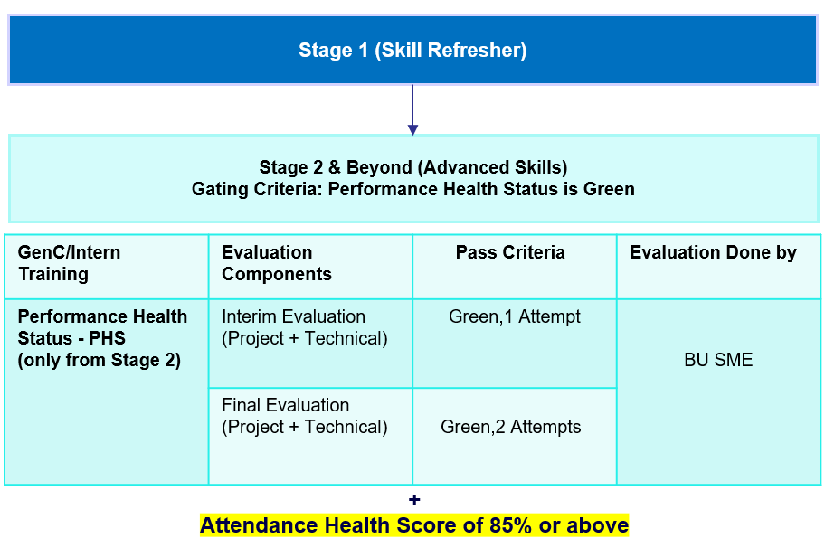

Internship stipend
All the GenC Interns will receive a monthly stipend of INR.12,000 based on their attendance. The final month's stipend will be paid upon successful completion of the curriculum. Intern attendance and performance play a crucial role in determining the stipend amount, highlighting the importance of active participation and engagement in the internship activities.
Note: For GenC Next and GenC Pro, the stipend amount may vary as specified in their internship offer letters.

GenC Internship skilling program guidelines
All GenC Interns are expected to adhere to and uphold the Cognizant Code of Ethics (“Code”) to help ensure that everything they do at Cognizant is in accordance with our standards of integrity.
The guidelines are to support the GenC Intern candidates stay focused and on-track w.r.t successful completion of the training program.

- Non-adherence of the below guidelines for more than 2 times to any of the below will be considered as a breach leading to de-enrollment from Internship program and revocation of LOI.
    - Code of Ethics
    - Adherence to Attendance*
    - Integrity in assessments**
    - Dress code
    - Adherence to communication Protocols

Note:
- In case of a breach in any of the above stated, the GenC Intern candidate will be issued a warning by the respective Batch Owner.
- It is recommended that the associate responds to the warning mailer with an explanation.
- If any GenC Intern candidate receives more than two warnings, it will result in immediate de-enrollment from the GenC Intern skilling program and revocation of LOI.
- The GenC Batch Owner can also write to the ‘Grievance cell’: GrievanceCoreTeam@cognizant.com regarding the breach as applicable.
- Non-Adherence to attendance requirements * & lack of integrity in assessments** will lead to stringent disciplinary action as per organization policies, including in de-enrollment from the Internship program and revocation of the LOI.
Below are the details and links of the policies and guidelines which will govern the GenC Internship skilling program.
Policy/Guidelines | Description | Link
Code of ethics | The behavior and professionalism of each Associate are critical to creating a safe and harmonious work environment where everyone can thrive and be stewards of Cognizant’s reputation, impact, and success. | https://be.cognizant.com/documents/preview/406771/Core-Values-Code-of-Ethics
Integrity in assessments | Any learning and assessment are expected to be given by the GenCs in a very honest way. Plagiarism / copying / any malpractice has a zero tolerance
Dress code | Our Dress code policy expects our employees to use their best judgment in deciding how they dress at work.
Communication protocols | All Cognizant associates are expected to comply with the organization’s Communications & social media Policy | Cognizant 'Communications & Social Media' Policy
Acceptable use policy | https://be.cognizant.com/documents/preview/520827/Acceptable-Use-Policy
Social media security guidance | https://be.cognizant.com/documents/preview/693393/Social-Media-Security-Guidance
Social media security quick tips | https://be.cognizant.com/documents/preview/693392/Social-Media-Security-Quick-Tips
Prevention of Sexual Harassment Policy - India | India Benefits - Policies (cognizant.com) - Document Preview - Prevention of Sexual Harassment Policy - India (cognizant.com)  In case of any SH related issues, kindly reach out directly to your location Prevention of Sexual Harassment Committee. Refer to the above policy link for email id of the location wise committee.

Code of Ethics - Guiding Principles
Misconduct can be broadly defined as a behavior or a failure to act in line with the company’s values, standards, policies, procedures, or other documents regulating the employment relationship.
The list below provides examples of misconduct; however, this is only illustrative and not deemed to be an exhaustive list.

Employee Relations matters

- Refusing to follow reasonable work instructions from a supervisor
- Habitual absenteeism and late reporting to work,
- unscheduled or unapproved leave impacting individual performance or teamwork.
- Negative language in the Work Environment
- Behaviors impacting productivity.
- Inter-personal conflict
- Borrowing and lending money to peers
- Inappropriate leadership behavior

Attendance Health status Guidelines
In-person training mode

- All GenC Intern candidates are expected to be available for the training at a physical location for all the 5 days in a week.
- Attendance at the physical location must be at least 85% every month to continue in the GenC internship skilling program and successfully complete the program.
- The TruTime hours logged should comply to Cognizant Working Hours guidelines
- 100% attendance is mandatory in all Instructor led sessions (ILT)
- The total number of hours for mandatory video-based sessions (both technical & behavioural sessions) will be considered for AHS calculation.
  - Intern candidate must be on video to have attendance for all VILT (Virtual Instructor Led Training) sessions.
    - Any breach of this evidenced in email with a concern raised by instructor/Batch Owner/LnD team will call for attendance not marked for the session and invite a warning resulting in consequence.
Virtual training mode

- All Intern candidates are required to be available for the training for all the 5 days in a week.
- All candidates must log into the Cognizant/vendor platform from morning 8.30 am to evening 6.30 pm or for the duration specified by the vendor except during break periods.
- Attendance must be recorded daily by the Batch Owner/ vendor training Lead when the GenC is in video mode.
- Interns must maintain a minimum of 85% attendance every month to successfully complete the program.
- 100% attendance is mandatory in all Virtual Instructor led sessions (VILT) for AHS calculation.
  - Intern candidates must be on video to have their attendance recorded for all VILT sessions.
  - Attendance will be taken randomly more than once, throughout the day. If a candidate is not available during any of these instances, they will be marked as absent.
  - Any breach of this policy, evidenced by an email with concerns raised by the instructor, Batch Owner, LnD team or vendor, will result in attendance not being marked for the session and may invite a warning with consequences.

AHS RAG
- The GenC Intern candidate attendance will be reported as AHS RAG
- GenC Intern candidate Intern candidate attendance reports will be generated every fortnight and the cumulative weekly AHS RAG status for each month must be in “Green”
- The AHS RAG status will be calculated and reported based on:
    - TruTime hours
    - Attendance in mandatory ILT/VILT sessions (manual report of both technical & behavioural sessions)
85% attendance in both the above parameters is mandated. AHS calculation matrix will be as below:
Actual Trutime | Actual session hours reported | RAG
>=85% | >=85% | Green
>=80% & <85% | >=85% | Amber
>=85% | >=80 & <85% | Amber
<85% | <85% | Red

AHS Consequence
Monthly AHS RAG | Consequence
 | Interns
Green | Continue with the skilling program
Amber | De-enrolment from the skilling program.  revoked LOI
Red

Internship leave policy
- Leaves are not permitted during GenC Internship skilling program.
- Attendance to be followed as per the AHS guidelines
- It is mandatory to be in-person or on video for VILT sessions (concern raised by facilitator will be a breach)
- Uninformed leaves of more than 3 days will lead to consequence
- Examination breaks not to exceed 5 working days (validated with college confirmed exam dates)
- 3 to 4 months in office is mandatory. If the trainees do not have 85% attendance in a month (both physical & virtual), it would lead to program de-enrolment in the 1st week of the subsequent month.
- Leave approvals to be taken in advance through their Batch Owner – Validated medical leaves from Cognizant medical team only will be permitted
- Notify the Batch Owner immediately for any Sick/Emergency leave – medical reports to be validated through Cognizant medical team
- All other leaves in any other reasons/categories would have an impact on the AHS attendance. Any uninformed leave(s) would lead to consequence as per AHS guidelines.
- Prior approved leaves aligned with college TPO would be required for the ‘Exam breaks’ (if required and applicable) and would be to the max of 5 days only.
- GenC Intern candidates are expected to have uninterrupted access to office mail and are always reachable on mobile phone numbers and MS Teams
- Attendance proxy both giving on behalf of others or availing the act would warrant serious consequence.
- Uninformed Leave >3 days will be moved to No-Show case and Internship abandonment will be initiated for GenC Intern candidates

Break Scenario

In cases where a GenC intern candidate is unable to attend training for more than five consecutive working days due to genuine medical or personal emergencies, they may be considered for movement to a Break Cohort, subject to approval from the Program Manager. Once approved, the Batch Owner will update the CRecruit and coordinate with the Supply Management Team to initiate the process. The intern should be informed in advance, and a tentative rejoining date must be obtained. Upon return, the intern will be mapped to a cohort based on current demand, which may differ from their original training track. Flexibility in accepting the available technology track is expected.

During the break period, the intern is advised to apply for Leave/LOP, which may also be initiated by the Batch Owner in HCM. If the intern does not report back on the agreed date and remains unresponsive for three working days, a Job Abandonment (JA) will be raised on the fourth day.

Rejoining scenarios are handled as follows:

- If the intern returns before the agreed date, they must obtain approval from the Batch Owner to cancel the LOP and raise a GSD request.
- If the intern returns on the agreed date, the Batch Owner will confirm cohort availability with the Supply Management Team and facilitate reassignment accordingly.

Throughout the process, the Batch Owner must ensure timely communication with all relevant stakeholders, including the Trainer, Program Managers, Platform Team, and Supply Management Team, to ensure a smooth transition and continuity in training.

Integrity in Assessments
As per the current model, assessments are designed as practice tests to evaluate Intern knowledge and skills. These skill/knowledge assessments are conducted as time-bound and randomized from a pool of questions with online/AI-based proctoring.
GenCs are evaluated through SME evaluations as part of the continuous evaluation and graduation process for Classroom/virtual skilling based on Cognizant business demands, which involve one-on-one interviews conducted by Cognizant SMEs
The SME evaluation will be a single event covering both technical and project implementation aspects conducted at two checkpoints during the skilling phase: (i) Interim Evaluation (ii) Final evaluation.
Below are the channels and processes being followed:
  - Proctored via in-person invigilation in Cognizant premises or live video proctoring if it is a virtual assessment. Cognizant has sole discretion on whether these evaluations are conducted virtually or in-person
  - Scheduled and recorded evaluations (Laptop required)
Any learning and assessment are expected to be given by the GenCs in a very honest way. Plagiarism / copying / any malpractice has zero tolerance.
The type of disciplinary action(s) would be based on multiple factors attached to the incident and incidents with high severity may call for stringent disciplinary action as per organization policies.

What constitutes Malpractice
S. No | Scenarios | S. No | Scenarios
1 | Trying to capture and leak questions and/or answers, in ANY mode – mobile pictures, screenshots, streaming etc., | 11 | False declaration of authenticity in relation to the submission of coursework to become eligible for a test.
2 | Copying code or answers or helping to copy from ANY source | 12 | Wasting an attempt to just look at or capture questions
3 | Informing any other parties about the details of the questions and answers, either before or after the assessment through any medium, including verbal or electronic. | 13 | Spurious complaints about system or infra related issues to explain failed attempt
4 | Having someone else take the test for you or help you with the answers in any way or mode. | 14 | Any attempt to compromise the integrity of the exam through any electronic or non-electronic method
5 | Running a parallel test session to gauge questions. | 15 | Trying to look in the other person’s desktop in the assessment hall
6 | Attempt to take assessments in groups | 16 | Discussion in the assessment hall before starting the test/ while attempting or even after finishing your test
7 | Using any electronic devices to capture exam related data or look for answers through any channels. | 17 | Trying to pass answers via rough sheet or any by any other source.
8 | Fabrication of results or evidence | 18 | Using Bluetooth devices during the assessment
9 | Stepping out of assessment hall more than once for drinking water or any other personal reasons. | 19 | Using nonverbal communication facial expressions, gestures, paralinguistics (such as loudness or tone of voice), body language, eye gaze
10 | Carrying any additional paper, cheat sheet to the assessment hall

Deployment guidelines

During the internship period and upon onboarding as a full-time employee, trainees will be required to demonstrate:

- Flexibility to work out of any of our Cognizant location(s), as per the training/ project requirements.
- Readiness to work in any shift, as per the training/project requirements.
- Willingness to work in the technology aligned with the final graduated skilling track.

Employment agreement as full-time employee shall be subject to and effective only upon successful completion of the GenC program and background verification

Communication protocols

GenC Program Communication Escalation Matrix
“Whom shall I reach out to in case of any query”

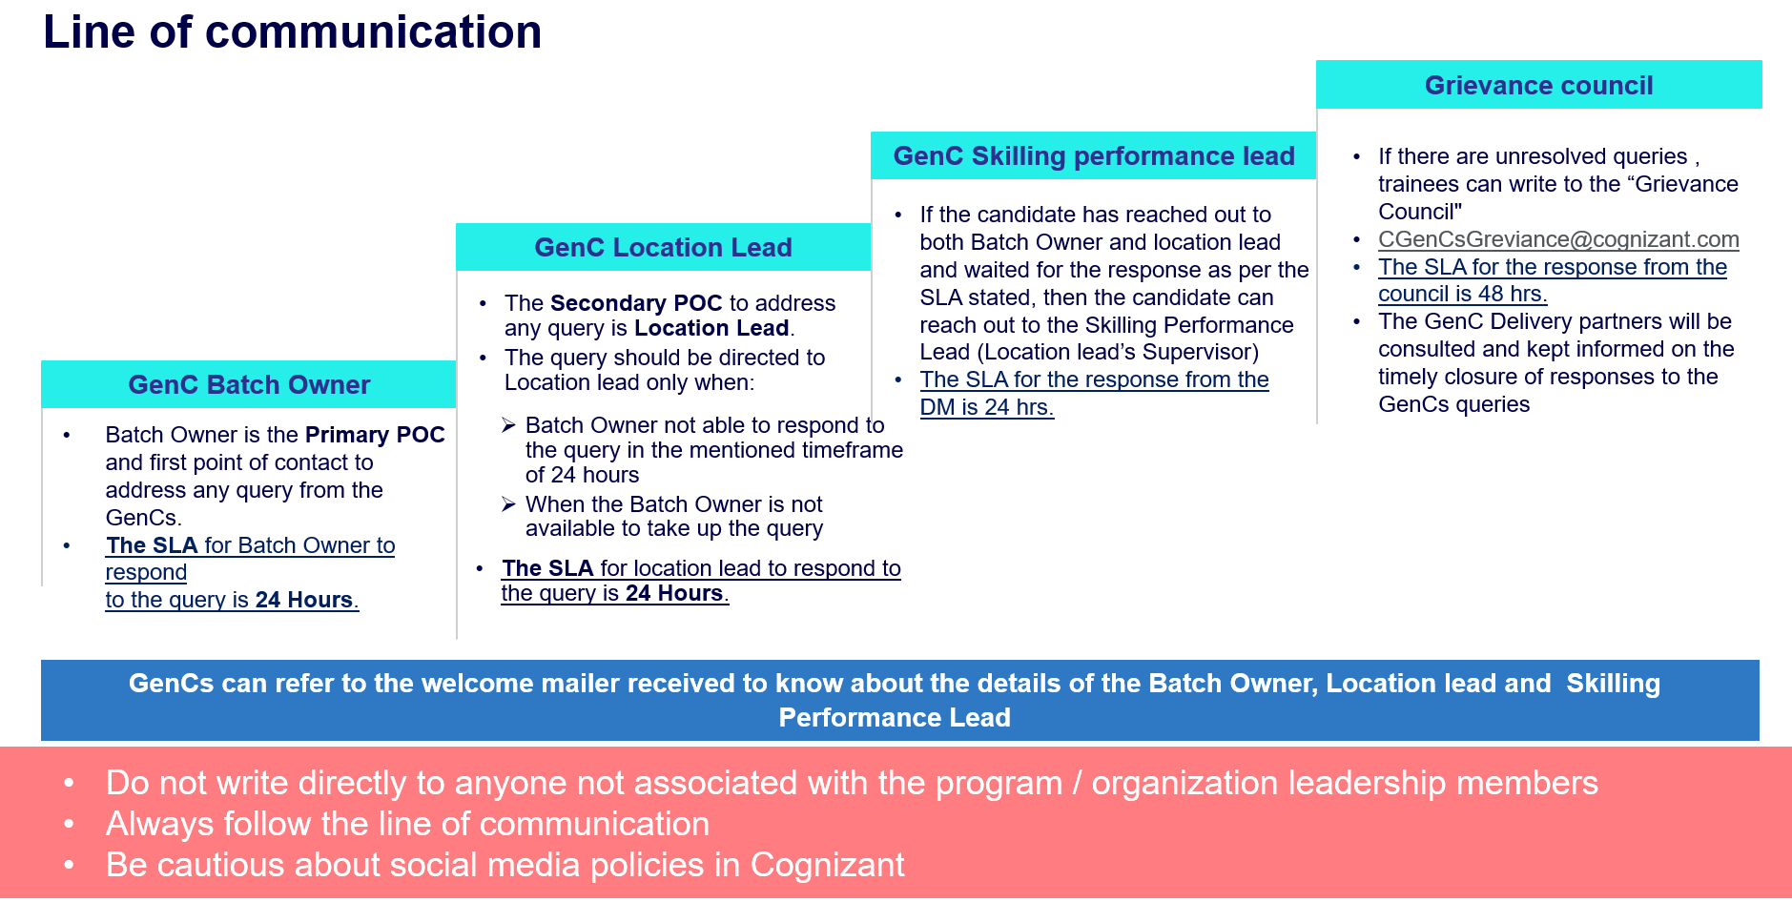

Mail format
It is highly recommended that the GenC Intern candidates follow the format below while writing regarding their queries for faster resolution

Mail Template
Subject: <<Cohort Code>>_<<Candidate ID>> - brief of the issue/query
Candidate ID
Name
DOJ | DD-MM-YY
SL
Cohort Code
Batch Owner Name
Delivery Lead Name
Have you reached out to your Batch Owner and SL POC earlier? | Yes/No/NA  If no, reach out to your respective PoC. Please send this query to DL only if it is not addressed by both your Batch Owner/Delivery Lead.
Query not addressed by Leads/Batch Owners | Explain in 2-3 lines. Attach email proof of the query which was not addressed by Batch Owner/Lead within 48Hours

GenC Grievance cell
The objective of the grievance cell is to provide good learning experience and working relationships for the GenC Intern candidates throughout their journey with the GenC skilling program.
The cell encourages the GenC Intern candidates to express their grievances or problems freely and frankly, without any fear of being victimized. The grievance cell will focus on advising the candidates to show utmost restraint and patience whenever any issue or challenge arises, and to follow the escalation matrix rather than writing to Cognizant leadership or in the public domain.
Additionally, the cell advises all GenC program POCs to be more approachable to the GenC Intern candidates and to not be unresponsive to the candidates' concerns. concerns.

How does the grievance cell work?
Raising a grievance is a 3 steps process wherein the GenC Intern candidates can log their grievance to the cell which will be tracked, monitored, and closed by the Grievance committee
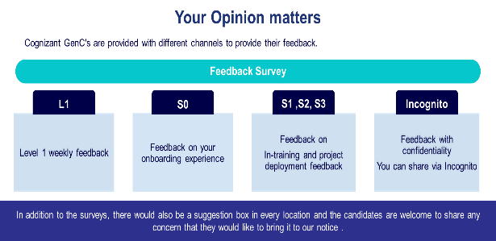
    - Through Incognito survey which will be launched in a specified frequency/timeline during the skilling journey
    - Common mailbox for Grievance GrievanceCoreTeam@cognizant.com where the concerns can be emailed.
    - Suggestion drop box placed in all the physical location wherein the GenCs Intern candidates can drop a grievance note.
Link to Incognito survey: https://forms.office.com/r/6ZK0uBkEYJ

Grievance Categories

SME Evaluation failures in 1st, 2nd and both the attempts | Warning given by the Batch Owners on the guideline breach  - Dress code guideline violation  - Misconduct covering Behavioral, Values and Ethics etc.  - Malpractice aligned to lack of learning agility  - Communication breach  - Training at physical location and AHS attendance
Stipend not received on time/Stipend amount is incorrect
Issues with company assets
Issues with company learning platform
Issues with Internal & external SMEs conduct
Issues related to BGV, onboarding process and offer letter

Feedback communication to the GenC
Performance status will be communicated to GenC Intern candidates at the appropriate checkpoints and will be available on the GenC learning platform dashboard.
The consequence-based feedback will be provided to the GenC Intern candidates based on the performance status at Checkpoint.
- On Track for successful completion (Green)
- Improvement Recommended (Amber)
- Critical focus required on progress (Red)

Moonlighting guidelines for Internship Candidates
Moonlighting refers to the practice of engaging in secondary employment/Internship while maintaining a primary job/Internship. This can include freelance projects, part-time jobs, or starting a side business during off-duty hours.
- Disclosure Requirements: Candidates must disclose any secondary employment to Cognizant. This includes providing details about the nature of the work, responsibilities, deadlines, and any potential conflicts of interest. Transparency is crucial and ensure that Intern is relieved from the secondary job and does not interfere with the primary internship responsibilities.
- Conflict of Interest: Candidates must ensure that they are not involved in any secondary employment does not create a conflict of interest with their internship duties. Any situation that might compromise their ability to perform their primary responsibilities objectively and diligently must be disclosed and evaluated.
- Performance Impact: The primary focus should remain on fulfilling internship responsibilities. Undisclosed Moonlighting should not negatively impact the intern's performance or availability for internship tasks. Cognizant reserves the right to revoke Internship offer, if the GenC Intern is found involved in secondary employment that adversely affects the intern's performance.
- Confidentiality and Intellectual Property: Interns must adhere to confidentiality agreements and respect intellectual property rights.
- Monitoring and Compliance: Cognizant will monitor compliance with the moonlighting policy. Interns are expected to maintain high standards of professionalism and integrity in their primary Internship role.
- Consequences of Non-Compliance: Failure to comply with the moonlighting policy may result in disciplinary action, up to and including termination of the internship.
By following these guidelines, ensure GenC Interns comply with Cognizant policies, making sure the internship responsibilities are not compromised.

Outliers/Exceptions
Any GenC NOT falling under ‘Successfully completed’ or ‘Alternate Service Line’ will not be applicable for the report card from Cognizant GenC skilling program.

GenC Internship Skilling 2025
Performance Declaration Form
I ……………………………………………., undergoing skilling in the GenC Internship program via classroom/virtual mode will be obliged to abide by, acknowledge, and agree to the following:
“GenC Internship skilling completion guidelines 2025” applicable to all types of skilling programs
Successful completion of the internship skilling program is mandatory for eligibility for FTE onboarding.
Flexibility regarding location, shift, role, and technology is required during training and project deployment.
(Skilling/Re-skilling pre & post onboarding)
The GenC Internship skilling completion guidelines 2025 document outlines the guidelines and criteria for successful completion of the GenC Internship skilling program:
Performance Standards | Performance indicators such as Performance Health Status (PHS - GREEN), and Attendance Health Status (AHS – 85%) are mandatory for successful completion. If a GenC Intern candidate fails to meet the performance standards of the skilling program within the stipulated timeline, they will be de-enrolled from the program, and the Letter of Intent (LOI) will be revoked.
Hands-On Completion | 100% completion of hands-on exercises at each stage is mandatory for eligibility to progress to the next stage.
Mandatory Assessments | Clearing the Stage-1 assessment and final evaluation is mandatory for successful completion of training and eligibility for deployment to Business Units (BU) in skilling or re-skilling programs.
Zero Tolerance for Malpractices | Any form of malpractice will be dealt with zero tolerance, potentially leading to immediate de-enrollment from the program and revocation of the LOI.
Attendance Requirement | Interns must maintain a minimum of 85% attendance at the physical location every month to continue and successfully complete the program.
Exceptions | There could be exceptions to the applicability of evaluation components and deployment clauses based on demand and training outcomes, subject to ISL discretion and GenC program head approval.
Reporting Discrepancies | Any discrepancies or deviations observed in the defined process or procedure should be reported to the respective Learning point of contact immediately during the learning journey.
Concerns post-unsuccessful completion | Concerns raised after failing to meet the expected performance health indicators will not be considered as exceptions to the consequence management process.

Candidate Name: __________________________ Candidate ID : _______________
Location : ______________ Date: dd / mm / yy Signature :

